1) After calculating how many nodes per second, BFS search always had the highest nodes per second, then A\*star search, then lastly ID-DFS search. I also printed out the total processed nodes and the total time to analyze what was different for each search.

BFS has high nodes per second because it processes a larger amount of nodes than ID-DFS but also completes the search much quicker, making the nodes per second pretty high.

This makes sense because ID-DFS has to traverse all the way down before going sideways and then run the search again for every depth. There is also some inefficiency when the search wanders back up to a previous level, so it would take a longer time to find the solution, which causes the low nodes per second.

I was surprised with A\*star having pretty high nodes per second, but that’s because the search is very quick and also examines fewer nodes with the heuristic approach (small number divided by small) so the nodes per second would not be very small.

1) The searches from least nodes per second to highest nodes per second is: astar, ID-DFS, then BFS. The astar search has the least nodes per second because it has to run the heuristic function, and as explained in Optimize Level 1, it can be really inefficient to generate the taxicab distance each time, so astar would take more time.

BFS and ID-DFS searches had similar nodes per second, but ID-DFS has less nodes per second because it uses sets, which needs to make more memory space if they get filled with a lot of items. ID-DFS also has to create a copy set of the ancestors each time, which takes more time. BFS, on the other hand, has a high nodes per second because it doesn’t require outside algorithms and doesn’t have to create copies for each child.

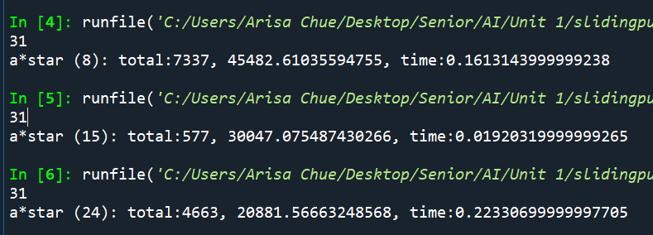

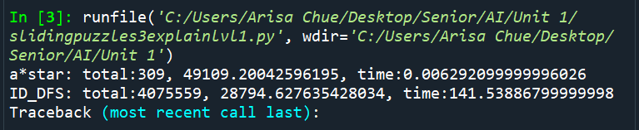



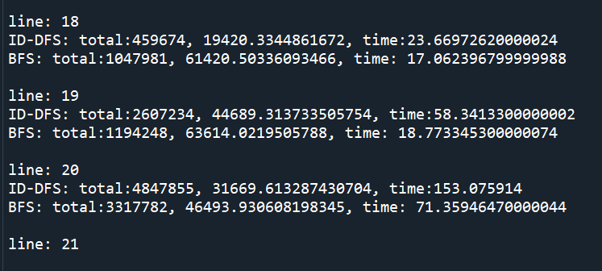

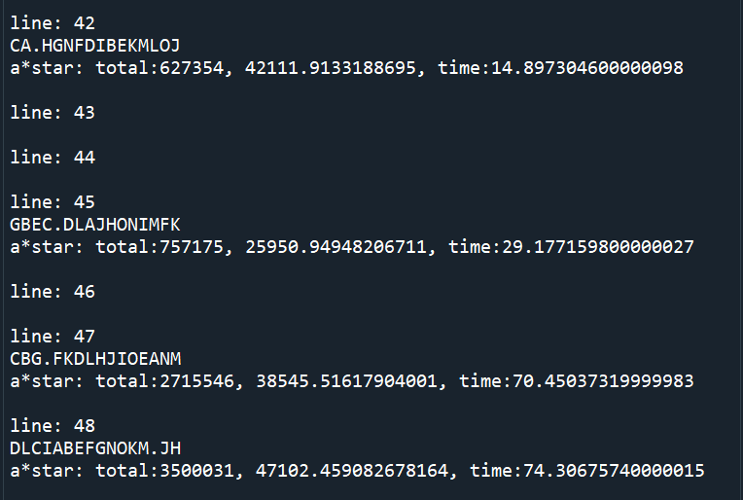

3) When I ran a 31-length puzzle for 8-puzzle, 15-puzzle, 24-puzzle, the nodes per second decreased as the puzzle size increased. This makes sense because it would take a longer time to solve a larger puzzle since you would have to add more children to the heap. A longer time would cause smaller nodes per second since the denominator increases.

1

ABCDEFGHIJKLMNOPQRSTUVW.X

ABCDEFGHIJKLMNOPQRS.UVWXT

2

ABCDEFGHIJKLMNOPQR.TUVWSX

ABCDEFGHIJKLMNOPQRSTUV.WX

ABCDEFGHIJKLMNOPQR.SUVWXT

ABCDEFGHIJKLMN.PQRSOUVWXT

3

ABCDEFGHIJKLMNOPQ.STUVRWX

ABCDEFGHI.KLMNJPQRSOUVWXT

ABCDEFGHIJKLMNOPQRSTU.VWX

ABCDEFGHIJKLMNOPQRXSUVW.T

ABCDEFGHIJKLMNOPQRT.UVWSX

ABCDEFGHIJKLMNOPQ.RTUVWSX

ABCDEFGHIJKLM.NPQRSOUVWXT

ABCDEFGHIJKLM.OPQRNSUVWXT

ABCDEFGHIJKLM.OPQRNTUVWSX

ABCDEFGHIJKLMNOPQ.RSUVWXT

4

ABCDEFGHIJKLMNOPQRXSUVWT.

ABCDEFGHIJKLMNOPQRXSUV.WT

ABCDEFGH.IKLMNJPQRSOUVWXT

ABCDEFGHIJKL.MOPQRNSUVWXT

ABCDEFGHIJKL.MOPQRNTUVWSX

ABCDEFGHIJKLMNOP.QRSUVWXT

ABCD.FGHIEKLMNJPQRSOUVWXT

ABCDEFGHIJKL.NOPQMSTUVRWX

ABCDEFGH.JKLMIOPQRNSUVWXT

ABCDEFGHIJKL.NOPQMRTUVWSX

ABCDEFGH.JKLMIOPQRNTUVWSX

ABCDEFGHIJKLMNOPQS.TUVRWX

ABCDEFGHIJKLMO.PQRNTUVWSX

ABCDEFGHIJKLMO.PQRNSUVWXT

ABCDEFGHIJKLMNOPQRST.UVWX

ABCDEFGHIJKLMN.PQRTOUVWSX

ABCDEFGHIJKL.MNPQRSOUVWXT

ABCDEFGHIJKLMNOP.QSTUVRWX

ABCDEFGHIJKLMNOP.QRTUVWSX

ABCDEFGHIJKL.NOPQMRSUVWXT

ABCDEFGHIJKLMNOP.RSTUQVWX

ABCDEFGHIJKLMNOPQRTXUVWS.

ABCDEFGHIJKLMNOPQWRSUV.XT

ABCDEFGHIJKLMNOPQWRTUV.SX

ABCDEFGHIJKLMSNPQR.OUVWXT

ABCDEFGH.JKLMINPQRSOUVWXT

5

ABCDEFGHIJK.LNOPQMRSUVWXT

ABCDEFGHIJKLMSNPQRXOUVW.T

ABCDEFGHI.KLMOJPQRNSUVWXT

ABCDEFGHIJKLN.OPQMRTUVWSX

ABCDEFGHIJKLMNOPQWRTUVS.X

ABCDEFGHIJKLMSNPQRO.UVWXT

ABCDEFGHJ.KLMINPQRSOUVWXT

ABCDEFGHIJKLN.OPQMRSUVWXT

ABCDEFGHIJKLMNO.PQRTUVWSX

ABC.EFGHDIKLMNJPQRSOUVWXT

ABCDEFGHJ.KLMIOPQRNSUVWXT

ABCDEFGHIJKLMNOPQSWTUVR.X

ABCDEFGHIJKLMNOPR.STUQVWX

ABCDEFG.HJKLMIOPQRNSUVWXT

ABCDEFGHIJK.MNOPLQRTUVWSX

ABC.EFGHDJKLMIOPQRNTUVWSX

ABCDEFGHIJKLRMOPQ.NSUVWXT

ABCDEFGHJ.KLMIOPQRNTUVWSX

ABCDEFGHIJK.LMNPQRSOUVWXT

ABCDEFGHIJKLN.OPQMSTUVRWX

ABCDEFG.HIKLMNJPQRSOUVWXT

ABCDEFGHNIKLM.JPQRSOUVWXT

ABC.EFGHDJKLMIOPQRNSUVWXT

ABCDEFG.IJKLHMOPQRNSUVWXT

ABCDEFGHIJK.LNOPQMSTUVRWX

ABC.DFGHIEKLMNJPQRSOUVWXT

ABCDEFGHIJK.LNOPQMRTUVWSX

ABCDEFGHIJKLMNOPQWRSUVX.T

ABCDEFG.HJKLMINPQRSOUVWXT

ABCDEFGHIJK.MNOPLRSTUQVWX

ABCDEFGHIJKLMNOPQRTXUVW.S

ABCDEFG.IJKLHNOPQMRTUVWSX

ABCDEFGHIJKLRMNPQ.SOUVWXT

ABCDEFGHIJKLMNO.QRSTPUVWX

ABCDEFGHIJKLMNO.PQSTUVRWX

ABCDEFGHIJK.LMOPQRNSUVWXT

ABCDEFGHIJKLMNOPVQSTU.RWX

ABCDEFGHIJKLMNOPVQRTU.WSX

ABCDEFGHIJKLMNOPQRX.UVWTS

ABCDEFGHIJKLMNOPQ.XSUVRWT

ABCDEFGHIJKLMNO.PRSTUQVWX

ABCDEFGHIJKLMNOPVQRSU.WXT

ABCDEFGHIJKLM.OPQSNTUVRWX

ABCDEFGHIJK.MNOPLQSTUVRWX

ABCDEFGHIJK.LMOPQRNTUVWSX

ABCDEFG.IJKLHNOPQMSTUVRWX

ABC.EFGHDJKLMINPQRSOUVWXT

ABCDEFG.IJKLHNOPQMRSUVWXT

ABCDEFGHIJKLMOSPQRN.UVWXT

ABCDEFGHIJKLM.NPQRTOUVWSX

ABCDEFGHIJKLMSNPQ.ROUVWXT

ABCDEFGHIJKLMNOPQWRSU.VXT

ABCDEFG.IJKLHMOPQRNTUVWSX

ABCDEFGHI.KLMNJPQRTOUVWSX

ABCDEFGHIJKLMOTPQRN.UVWSX

ABCDEFGHIJK.MNOPLQRSUVWXT

ABCDEFGHI.KLMOJPQRNTUVWSX

ABCDEFGHIJKLMNOPQWRTU.VSX

ABCDEFGHIJKLMNO.PQRSUVWXT

ABCDEFG.IJKLHMNPQRSOUVWXT

ABCDEFGHIJKLMNOPQST.UVRWX

ABCDEFGHIJKLMNOPQRXSU.VWT

ABCDEFG.HJKLMIOPQRNTUVWSX

ABCDEFGHIJKLRMOPQ.NTUVWSX